Contents
Research questions 2
a) What is an autopilot? 2
b) What are the inputs & outputs of Autopilot system onboard an airplane? 2
Inputs: 2
Outputs: 2
c) What would be the role of the pilot in an airplane equipped with an autopilot? 2
d) What is the difference between Autopilot & SAS? 3
e) What is the role of the onboard sensors like (GPS, gyroscopes, ...etc.)? give example. 3
Flight Mechanics review: 4
a) State the general rigid body dynamics (RBD) equations in 3D space 4
Assume a mass element at a rigid body, the velocity of this mass w.r.t fixed axes: 4
By using the calculations of linear momentum: 4
By using the calculations of angular momentum: 5
we are dealing with an aircraft which means $Ixy=Iyz=0 symmetry cond.$ 6
Linear Velocities transformation: 7
Let’s apply the above transformation on the gravitational force of the airplane as following: 7
Angular velocities transformation: 7
b) Classify the upper equations into (Kinetics & Kinematics) equations 8
c) What are the assumptions introduced while deriving those equations? 8
d) State the set of equations added to the (RBD) equations to form the Fixed wing Airplanes (EOM) 8
e) Classify the airplanes EOM equations mathematically. 9
f) What is the difference between the (Body axes) and the (earth or inertial axes)? 9
g) What is the difference between the pitch angle (θ) and the angle of attack (α), and between the sideslip angle (β) and the heading angle (ψ)? 9
Numerical solutions of ODEs 10
Some numerical solving algorithms for ODE 10
The chosen method for solving the aircraft EOM. 10
The general solution of 4th order Runge-Kutta method 11
Appendix: MATLAB code 13

Autopilot literature review

Research questions

a) What is an autopilot?
An autopilot is a system that allows an airplane, marine vehicle, or spaceship to navigate without the need for constant manual control by a human operator. Human operators are not replaced by autopilots. Instead, the autopilot supports the driver in maintaining vehicle control.

b) What are the inputs & outputs of Autopilot system onboard an airplane?

Inputs:

Control Inputs:
- Radio Control Receivers
- MAVLink Data Streams, i.e., ground control stations or companion computers

Sensor inputs:
GPS, Compass, Airspeed, Rangefinders, IMU

Power Management Unit Inputs:
- Received Signal Strength Input (RSSI)
- Analog Airspeed Sensors

Outputs:
- ESCs (electronic circuit that controls and regulates the speed of an electric motor) for motors
- Servos for control surfaces
- Telemetry data
- Actuators and General Purpose I/O like LEDs, buzzers etc

c) What would be the role of the pilot in an airplane equipped with an autopilot?
The pilot sets the flight plan and turn on the autopilot sometimes the pilot reprograms the autopilot in case if worked incorrectly. autopilot is not smart enough to fly a plane by It self

d) What is the difference between Autopilot & SAS?
SAS (Stability augmentation system) generally used during low and slow maneuvering where the pilot may be making constant attitude changes in preparation for landing.
Autopilot do same functions as SAS in addition it provides more functions, Autopilot Is more sophisticated than SAS

e) What is the role of the onboard sensors like (GPS, gyroscopes, ...etc.)? give example.
Sensors provide the autopilot computers with data like speed, coordinates, position so the computers can estimate the states and give the correct control actions to the actuators for example
Gyroscope an IMU supplies the autopilot with position data so if the airplane in incorrect position it gives the actuator signal so that it can adjust position

Flight Mechanics review:

a) State the general rigid body dynamics (RBD) equations in 3D space

Assume a mass element at a rigid body, the velocity of this mass w.r.t fixed axes:
$$\overset{⃑}{V}= \overset{⃑}{V_{c}}+ \frac{d\overset{⃑}{r}}{dt} (1)$$

By using the calculations of linear momentum:
The force at this point is given by:
$$δ\overset{⃑}{F}= δm\frac{d\overset{⃑}{V}}{dt} (2)$$
Sub. By (1) in (2) and take summation for all point masses is in the rigid body:
$$\overset{⃑}{F}= \sum{δ\overset{⃑}{F}}= \frac{d}{dt} \sum{(}\overset{⃑}{V_{c}}+ \frac{d\overset{⃑}{r}}{dt})δm$$
$$\overset{⃑}{F}=m\frac{d\overset{⃑}{V_{c}}}{dt}+ \frac{d}{dt}\sum{\frac{d\overset{⃑}{r}}{dt}} δm= m\frac{d\overset{⃑}{V_{c}}}{dt}+\frac{d^{2}}{dt^{2}}\sum{r}δm$$
Since: $rδm=0$
$$∴\overset{⃑}{F}= m\frac{d\overset{⃑}{V_{c}}}{dt}$$
From general definition:
$${\frac{d\overset{⃑}{A}}{dt}}_{I}= {\frac{d\overset{⃑}{A}}{dt}}_{B }+ ω × \overset{⃑}{A}$$
So:
$$\overset{⃑}{F}= m\frac{d\overset{⃑}{V_{c}}}{dt} +m(ω × \overset{⃑}{V_{c}})$$
Where:
$$\overset{⃑}{F}= F_{x}\overset{⃑}{i}+ F_{y}\overset{⃑}{j}+ F_{z}\overset{⃑}{k}, \overset{⃑}{ω}=P\overset{⃑}{i}+q\overset{⃑}{j}+r\overset{⃑}{k}, \overset{⃑}{V_{c }}= ui+vj+wk$$
So:
$$F_{x}=m(\dot{u}+qw-rv)$$
$$F_{y}=m(\dot{v}+ru-pw)$$
$$F_{z}=m\left(\dot{w}+pv-qu\right)$$

By using the calculations of angular momentum:

$$δ\overset{⃑}{M}= \frac{d}{dt}δ\overset{⃑}{H}= \frac{d}{dt}\left(\overset{⃑}{r} ×\overset{⃑}{V}\right)δm$$
By using the upper general definition:
0
$${\frac{d\overset{⃑}{r}}{dt}}_{I}= {\frac{d\overset{⃑}{r}}{dt}}_{B }+ ω × \overset{⃑}{r}$$

$$Then: \overset{⃑}{H}= \sum{δ\overset{⃑}{H}}= \sum{\left(\overset{⃑}{r} ×\overset{⃑}{V_{c}}\right)δm+ \sum{\left[r ×\left(ω ×\overset{⃑}{r}\right)\right]}}δm$$
Where: $\overset{⃑}{r}=xi+yj+zk$
Then:
$$H_{x}=p\sum{(y^{2}+ z^{2})}δm-q\sum{xy δm-r\sum{xz δm}}$$
$$H_{y}=-p\sum{xy}δm+q\sum{(x^{2}+z^{)2} δm-r\sum{yz δm}}$$
$$H_{z}=-p\sum{xz}δm+q\sum{yzδm-r\sum{(x^{2}+y^{2}) δm}}$$

By expressing the above equations in terms of moment of inertia about body axes:
$$H_{x}=pI_{x}-qI_{xy}-rI_{xz}$$
$$H_{y}=-pI_{xy}+qI_{y}-rI_{yz}$$
$$H_{z}=-pI_{xz}-qI_{yz}+rI_{z}$$
Since:
$$\overset{⃑}{M}= \frac{d}{dt}\overset{⃑}{H}= {\frac{d\overset{⃑}{H}}{dt}}_{B}+\overset{⃑}{ω} ×\overset{⃑}{H}$$
$$L= \dot{H_{x}}+{qH}_{z}-rH_{y}$$
$$M= \dot{H_{y}}+{rH}_{x}-pH_{z}$$
$$N= \dot{H_{z}}+pH_{y}-qH_{x}$$

we are dealing with an aircraft which means $I_{xy}=I_{yz}=0 \left(symmetry cond.\right)$
Then: The airplane translational and rotational EOM are:
$$F_{x}=m(\dot{u}+qw-rv)$$
$$F_{y}=m(\dot{v}+ru-pw)$$
$$F_{z}=m\left(\dot{w}+pv-qu\right)$$

$$L=I_{x}\dot{p}-I_{xz}\dot{r}+qr\left(I_{z}-I_{y}\right)-I_{xz}pq$$
$$M=y\dot{q}+rp\left(I_{x}-I_{z}\right)+I_{xz}\left(p^{2}-r^{2}\right)$$
$$N={-I}_{xz}\dot{p}+I_{z}\dot{r}+pq\left(I_{y}-I_{x}\right)+I_{xz}qr$$

By adding the calculations of earth axis to body axis transformation:
$$\left[\begin{aligned}X_{1} \\ Y_{1} \\ Z_{1}\end{aligned}\right]= \left[\begin{matrix}cosψ & sinψ & 0 \\ -sinψ & cosψ & 0 \\ 0 & 0 & 1\end{matrix}\right] \left[\begin{aligned}X_{E} \\ Y_{E} \\ Z_{E}\end{aligned}\right]$$
$$F_{1}=R_{3}\left(ψ\right)F_{E}$$
$$\left[\begin{aligned}X_{2} \\ Y_{2} \\ Z_{2}\end{aligned}\right]=\left[\begin{matrix}cosθ & 0 & -sinθ \\ 0 & 1 & 0 \\ sinθ & 0 & cosθ\end{matrix}\right] \left[\begin{aligned}X_{1} \\ Y_{1} \\ Z_{1}\end{aligned}\right]$$
$$F_{2}=R_{2}\left(θ\right)F_{1}= R_{2}\left(θ\right)R_{3}\left(ψ\right)F_{E}$$
$$\left[\begin{aligned}X_{B} \\ Y_{B} \\ Z_{B}\end{aligned}\right]= \left[\begin{matrix}1 & 0 & 0 \\ 0 & cosϕ & sinϕ \\ 0 & -sinϕ & cosϕ\end{matrix}\right] \left[\begin{aligned}X_{2} \\ Y_{2} \\ Z_{2}\end{aligned}\right]$$
$$F_{B}=R_{1}\left(ϕ\right)F_{2}= R_{1}\left(ϕ\right)R_{2}\left(θ\right)R_{3}\left(ψ\right)F_{E}$$

Linear Velocities transformation:
$${\left\{\dot{\begin{aligned}X \\ \dot{\begin{aligned}Y \\ \dot{Z}\end{aligned}}\end{aligned}}\right\}}_{E}= \left[\begin{matrix}C_{θ}C_{ψ} & S_{ϕ}S_{θ}C_{ψ}-C_{ϕ}S_{ψ} & C_{ϕ}S_{θ}C_{ψ}+S_{ϕ}S_{ψ} \\ C_{θ}S_{ψ} & S_{ϕ}S_{θ}S_{ψ}+C_{ϕ}C_{ψ} & C_{ϕ}S_{θ}S_{ψ}-S_{ϕ}C_{ψ} \\ -S_{θ} & S_{θ}C_{θ} & C_{ϕ}C_{θ}\end{matrix}\right]{\left\{\begin{aligned}u \\ v \\ w\end{aligned}\right\}}_{B}$$

Let’s apply the above transformation on the gravitational force of the airplane as following:
$${\overset{⃑}{F}}_{{Gravity}_{B}}= \left[\begin{matrix}1 & 0 & 0 \\ 0 & cosϕ & sinϕ \\ 0 & -sinϕ & cosϕ\end{matrix}\right]\left[\begin{matrix}cosθ & 0 & -sinθ \\ 0 & 1 & 0 \\ sinθ & 0 & cosθ\end{matrix}\right]\left[\begin{matrix}cosψ & sinψ & 0 \\ -sinψ & cosψ & 0 \\ 0 & 0 & 1\end{matrix}\right]{\left[\begin{aligned}0 \\ 0 \\ mg\end{aligned}\right]}_{E}$$
$${\overset{⃑}{F}}_{{Gravity}_{B}}= {\left[\begin{aligned}-mgsinθ \\ mgsinϕcosθ \\ mgsinθcosϕ\end{aligned}\right]}_{B}$$
Then:
$$-mgsinθ+{F_{T}}_{X}=m(\dot{u}+qw-rv)$$
$$mgsinϕcosθ+{F_{T}}_{Y} =m(\dot{v}+ru-pw)$$
$$mgsinθcosϕ + {F_{T}}_{Z}=m\left(\dot{w}+pv-qu\right)$$

Angular velocities transformation:
$$\overset{‾}{\dot{Ψ}}=\overset{˙}{Ψ}{\overset{‾}{K}}_{1}=\overset{˙}{Ψ}{\overset{‾}{K}}_{2}$$ | $$\overset{‾}{\dot{θ}}=\overset{˙}{θ}\overline{{\overset{˙}{j}}_{2}}=\overset{˙}{θ}\overline{{\overset{˙}{j}}_{3}}$$ | $$\overset{‾}{\dot{Φ}}=\overset{˙}{Φ}{\overline{\dot{i}}}_{3}=\overset{˙}{Φ}\overline{\dot{i}}$$
 | 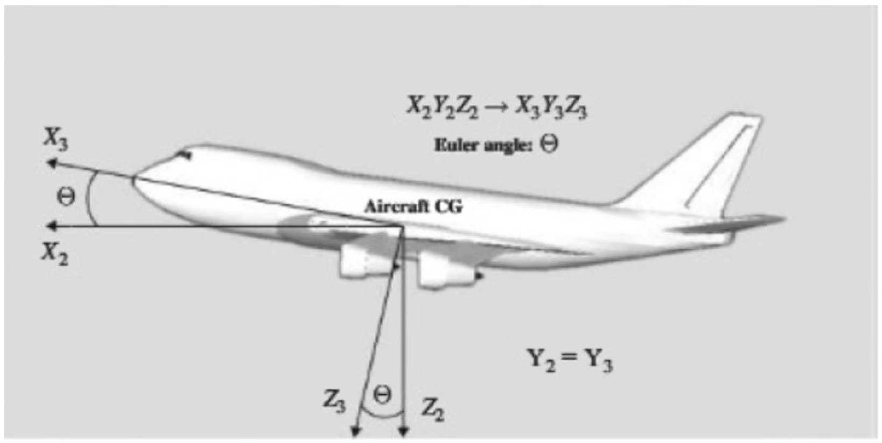 | 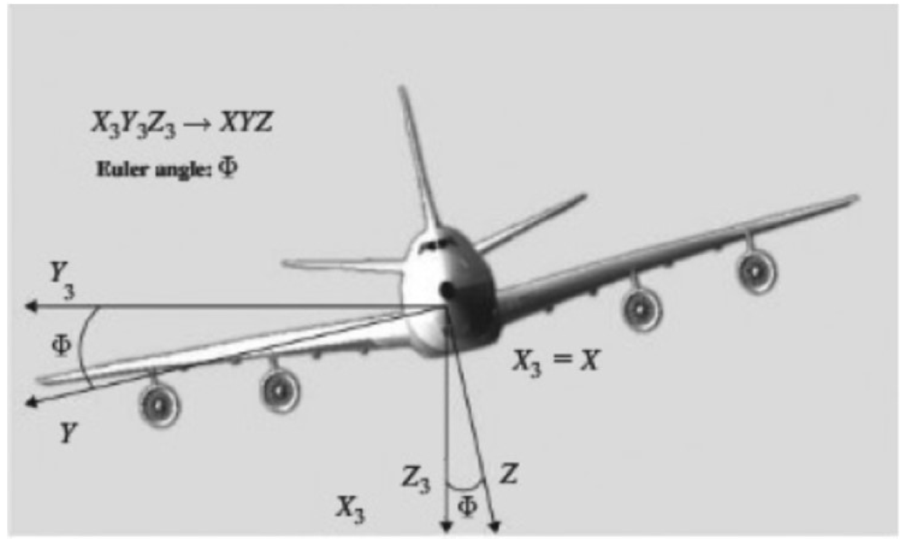
$$\overset{‾}{ω}=\overset{‾}{\dot{Ψ}}+\overset{‾}{\dot{θ}}+\overset{‾}{\dot{Φ}}=P\overline{\dot{i}}+Q\overline{\dot{j}}+R\overset{‾}{k}=\overset{˙}{Ψ}{\overset{‾}{K}}_{2}+\overset{˙}{θ}\overline{{\overset{˙}{j}}_{3}}+\overset{˙}{Φ}\overline{\dot{i}} \\ \left\{\begin{matrix}i_{3} \\ j_{3} \\ k_{3}\end{matrix}\right\}=\left[\begin{matrix}1 & 0 & 0 \\ 0 & \cos{Φ} & -\sin{Φ} \\ 0 & \sin{Φ} & \cos{Φ}\end{matrix}\right]\left\{\begin{matrix}i \\ j \\ k\end{matrix}\right\}$$
$$j_{3}=\cos\left(Φ\right)\overline{\dot{j}}-\sin\left(Φ\right)\overline{k}$$
$$k_{3}=\sin\left(Φ\right)\overline{\dot{j}}+\cos\left(Φ\right)\overline{k} \\ k_{2}=-\sin\left(θ\right)i+\cos\left(θ\right)\left(\sin\left(Φ\right)j+\cos\left(Φ\right)k\right)=-sin\left(θ\right)i+\cos\left(θ\right)\sin\left(Φ\right)j+\cos\left(θ\right)\cos\left(ϕ\right)k \\ \overset{‾}{ω}=Pi+Qj+R\overset{‾}{k}=\overset{‾}{\dot{Ψ}}+\overset{‾}{\dot{θ}}+\overset{‾}{\dot{Φ}}=\overset{˙}{Ψ}k_{2}+\overset{˙}{θ}j_{3}+\overset{˙}{Φ}i$$
$=\overset{˙}{Ψ}(-sin\left(θ\right)i+\cos\left(θ\right)\sin\left(Φ\right)j+\cos\left(θ\right)\cos\left(ϕ\right)k) +\overset{˙}{θ}\left(\cos\left(Φ\right)\overline{\dot{j}}-\sin\left(Φ\right)\overline{k}\right)+\overset{˙}{Φ}i$
$$∴\left\{\begin{aligned}P \\ Q \\ R\end{aligned}\right\}= \left[\begin{matrix}1 & 0 & -sinθ \\ 0 & cosϕ & cosθsinϕ \\ 0 & -sinϕ & cosϕcosθ\end{matrix}\right]\left\{\dot{\begin{aligned}ϕ \\ \dot{\begin{aligned}θ \\ \dot{ψ}\end{aligned}}\end{aligned}}\right\}$$

b) Classify the upper equations into (Kinetics & Kinematics) equations
Kinetics equations | Kinematics equations
$$-mgsinθ+{F_{T}}_{X}=m(\dot{u}+qw-rv)$$  $$mgsinϕcosθ+{F_{T}}_{Y} =m(\dot{v}+ru-pw)$$  $$mgsinθcosϕ + {F_{T}}_{Z}=m\left(\dot{w}+pv-qu\right)$$  $$L=I_{x}\dot{p}-I_{xz}\dot{r}+qr\left(I_{z}-I_{y}\right)-I_{xz}pq$$  $$M=y\dot{q}+rp\left(I_{x}-I_{z}\right)+I_{xz}\left(p^{2}-r^{2}\right)$$  $$N={-I}_{xz}\dot{p}+I_{z}\dot{r}+pq\left(I_{y}-I_{x}\right)+I_{xz}qr$$ | $\left\{\begin{aligned}P \\ Q \\ R\end{aligned}\right\}= \left[\begin{matrix}1 & 0 & -sinθ \\ 0 & cosϕ & cosθsinϕ \\ 0 & -sinϕ & cosϕcosθ\end{matrix}\right]\left\{\dot{\begin{aligned}ϕ \\ \dot{\begin{aligned}θ \\ \dot{ψ}\end{aligned}}\end{aligned}}\right\}$  $${\left\{\dot{\begin{aligned}X \\ \dot{\begin{aligned}Y \\ \dot{Z}\end{aligned}}\end{aligned}}\right\}}_{E}= \left[\begin{matrix}C_{θ}C_{ψ} & S_{ϕ}S_{θ}C_{ψ}-C_{ϕ}S_{ψ} & C_{ϕ}S_{θ}C_{ψ}+S_{ϕ}S_{ψ} \\ C_{θ}S_{ψ} & S_{ϕ}S_{θ}S_{ψ}+C_{ϕ}C_{ψ} & C_{ϕ}S_{θ}S_{ψ}-S_{ϕ}C_{ψ} \\ -S_{θ} & S_{θ}C_{θ} & C_{ϕ}C_{θ}\end{matrix}\right]{\left\{\begin{aligned}u \\ v \\ w\end{aligned}\right\}}_{B}$$

c) What are the assumptions introduced while deriving those equations?
The assumptions are:
- The body is rigid which means the mass is constant and there is no change in geometry (Stress calculations are neglected).
- Fix a body axis at the center of mass of the rigid body.

d) State the set of equations added to the (RBD) equations to form the Fixed wing Airplanes (EOM)
The additional EOM of airplanes:
→ The effect of the control surfaces: $δ_{e}$ , $δ_{a}$ , $δ_{r}$ , $δ_{T}$
- The change in forces:
$$∆X=m \left(\frac{∂X}{∂u} ∆u+\frac{∂X}{∂w} ∆w+ \frac{∂X}{∂δ_{e}} ∆δ_{e}+ \frac{∂X}{∂δ_{T}} ∆δ_{T}\right)$$
$$∆Y=m \left(\frac{∂Y}{∂v} ∆v+\frac{∂Y}{∂β} ∆β+ \frac{∂Y}{∂δ_{a}} ∆δ_{a}+ \frac{∂Y}{∂δ_{r}} ∆δ_{r}\right)$$
$$∆Z=m \left(\frac{∂Z}{∂u} ∆u+\frac{∂Z}{∂w} ∆w+ \frac{∂Z}{∂\dot{w}} ∆\dot{w}+\frac{∂Z}{∂q} ∆q+ \frac{∂Z}{∂δ_{e}} ∆δ_{e}+ \frac{∂Z}{∂δ_{T}} ∆δ_{T}\right)$$

- The change in moments:
$$∆L=I_{xx} \left(\frac{∂L}{∂β} ∆β+\frac{∂L}{∂p} ∆p+\frac{∂L}{∂r} ∆r+ \frac{∂L}{∂δ_{r}} ∆δ_{r}+ \frac{∂L}{∂δ_{a}} ∆δ_{a}\right)$$
$$∆M=I_{yy} \left(\frac{∂M}{∂u} ∆u+\frac{∂M}{∂w} ∆w+ \frac{∂M}{∂\dot{w}} ∆\dot{w}+\frac{∂M}{∂q} ∆q+ \frac{∂M}{∂δ_{e}} ∆δ_{e}+ \frac{∂M}{∂δ_{T}} ∆δ_{T}\right)$$
$$∆N=I_{zz} \left(\frac{∂N}{∂β} ∆β+\frac{∂N}{∂p} ∆p+\frac{∂N}{∂r} ∆r+ \frac{∂N}{∂δ_{r}} ∆δ_{r}+ \frac{∂N}{∂δ_{a}} ∆δ_{a}\right)$$

e) Classify the airplanes EOM equations mathematically.
The EOMs are coupled, nonlinear and first order DE.

f) What is the difference between the (Body axes) and the (earth or inertial axes)?
- Body axes: they are a set of axes which are fixed at the body in its translational and rotations.
- Inertial axes: they are a set of axes which are fixed at a specified position on the ground.

g) What is the difference between the pitch angle (θ) and the angle of attack (α), and between the sideslip angle (β) and the heading angle (ψ)?
- Pitch angle: it’s formed due to rotation about y-axis.
- AOA: it’s formed due to a difference between the direction of flow and the plane wing.
- Sideslip angle: it’s formed due to due to lateral deviation between the plane and the direction of the flow.
- Yaw angle (heading): it’s formed due to due to the rotation about z-axis.

Numerical solutions of ODEs

Some numerical solving algorithms for ODE
one step methods, are methods that involve only $y_{i}$ and intermediate quantities to compute the next value $y_{i+1}$. In contrast, multi-step methods use more than the previous point
One-step methods, like:
Euler-Cauchy method
Improved Euler method
Raunge-Kutta method
Backward Euler method
Multistep methods, like:
Adams-Bash forth method
Adams-Moulton method
Other methods
Predictor-Corrector Methods
Exponential integrator methods

The chosen method for solving the aircraft EOM.
We choose to use Raunge-Kutta method since its one of the most accurate one step methods used in the numerical solutions, in addition it’s the method used in the MATLAB ODE45 algorithm.
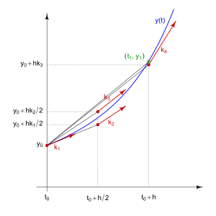
The order of the Raunge-Kutta indicates the number of slopes used in the approximation; so higher orders mean higher accuracy of the solution; the wights of the slopes is determined comparing the coefficients with Taylor expansion of the function.[1] anyway, the fourth order Raunge-Kutta is commonly as it gives good accuracy and acceptable computational power.

Initial conditions:
$$u_{0}, v_{0}, w_{0},x_{0}, y_{0}, z_{0}, θ_{0}, φ_{0}, ψ_{0}, p_{0}, q_{0}, r_{0}$$
Inputs:
$$δ_{a}, δ_{e}, δ_{r}, δ_{T}$$

Outputs:
Components of air craft velocity$: u , v , w$
Position: $x , y , z$
Euler angles: $θ , φ , ψ$
Angular velocity components: $p , q , r$

[1] for more details regarding the derivation of Raunge-Kutta method use the following link
https://www.math.hkust.edu.hk/~machas/numerical-methods-for-engineers.pdf?fbclid=IwAR1mOjc35AS3QV_ZuL0Z_nV8Ph3nCop4FlsaS_ueBMz31whmOBPh9LJ2GlM

The general solution of 4th order Runge-Kutta method

$$k_{1}=Δtf\left(t_{n},x_{n}\right)$$
$$k_{2}=Δtf\left(t_{n}+\frac{1}{2}Δt,x_{n}+\frac{1}{2}k_{1}\right)$$
$$k_{3}=Δtf\left(t_{n}+\frac{1}{2}Δt,x_{n}+\frac{1}{2}k_{2}\right)$$
$$k_{4}=Δtf\left(t_{n}+Δt,x_{n}+k_{3}\right)$$
$$x_{n+1}=x_{n}+\frac{1}{6}\left(k_{1}+2k_{2}+2k_{3}+k_{4}\right)$$
For the following system of ODEs
$$\begin{aligned}f=\frac{dy_{1}}{dt}=sin⁡(t)+cos⁡\left(y_{1}\right)+sin⁡\left(y_{2}\right) \\ g=\frac{dy_{2}}{dt}=cos⁡(t)+sin⁡\left(y_{2}\right)\end{aligned}$$
IC $@t=0, y_{1}=0, y_{2}=0$ $t_{f}=20 sec$ $n=100$ $h=\frac{Δt}{n}$
$$K_{1}=hf\left(t_{n},y_{n}^{1},y_{n}^{2}\right)$$ | $$q_{1}=hg\left(t_{n},y_{n}^{1},y_{n}^{2}\right)$$
$$K_{2}=hf\left(t_{n}+\frac{1}{2}h,y_{n}^{1}+\frac{1}{2}K_{1},y_{n}^{2}+\frac{1}{2}q_{1}\right)$$ | $$q_{2}=hg\left(t_{n}+\frac{1}{2}h,y_{n}^{1}+\frac{1}{2}K_{1},y_{n}^{2}+\frac{1}{2}q_{1}\right)$$
$$K_{3}=hf\left(t_{n}+\frac{1}{2}h,y_{n}^{1}+\frac{1}{2}K_{2},y_{n}^{2}+\frac{1}{2}q_{2}\right)$$ | $$q_{3}=hg\left(t_{n}+\frac{1}{2}h,y_{n}^{1}+\frac{1}{2}K_{2},y_{n}^{2}+\frac{1}{2}q_{2}\right)$$
$$K_{4}=hf\left(t_{n}+h,y_{n}^{1}+K_{3},y_{n}^{2}+q_{3}\right)$$ | $$q_{4}=hg\left(t_{n}+h,y_{n}^{1}+K_{3},y_{n}^{2}+q_{3}\right)$$

$$y_{n+1}^{1}=y_{n}^{1}+\frac{1}{6}\left(q_{1}+2q_{2}+2q_{3}+q_{4}\right)$$
$$y_{n+1}^{2}=y_{n}^{2}+\frac{1}{6}\left(k_{1}+2k_{2}+2k_{3}+k_{4}\right)$$

Appendix: MATLAB code
clc
clear All
close All

t1=0;
t2=20;
n=100;
h=(t2-t1)/n;
t=(linspace(t1,t2,n+1))';
y1=zeros(length(t),1);
y2=zeros(length(t),1);
y2(1)=1;
y1(1)=-1;

for n=1:length(t)-1
k1=h*(cos(t(n))+sin(y2(n)));
q1=h*(sin(t(n))+cos(y1(n))+sin(y2(n)));

k2=h*(cos(t(n)+0.5*h)+sin(y2(n)+0.5*k1));
q2=h*(sin(t(n)+0.5*h)+cos(y1(n)+0.5*q1)+sin(y2(n)+0.5*k1));

k3=h*(cos(t(n)+0.5*h)+sin(y2(n)+0.5*k2));
q3=h*(sin(t(n)+0.5*h)+cos(y1(n)+0.5*q2)+sin(y2(n)+0.5*k2));

k4=h*(cos(t(n)+h)+sin(y2(n)+k3));
q4=h*(sin(t(n)+h)+cos(y1(n)+q3)+sin(y2(n)+k3));

y2(n+1)=y2(n)+(1/6)*(k1+2*k2+2*k3+k4);
y1(n+1)=y1(n)+(1/6)*(q1+2*q2+2*q3+q4);
end

figure
hold on
plot(t,y1,'r')
plot(t,y2,'b')
legend({'y(1)','y(2)'},...
'Location','southeast','FontSize',8,'Interpreter','latex')
xlabel('$t$','Interpreter','latex','FontSize',13)
%% Check using ode45
[tv,Yv]=ode45(@sys_fun,[0 20],[-1 1]);
plot(tv,Yv(:,1),'r--','LineWidth',1.5)
plot(tv,Yv(:,2),'k--','LineWidth',1.5)
legend({'y(1)','y(2)','y(1)ode45','y(2)ode45'},...
'Location','southeast','FontSize',8,'Interpreter','latex')
xlabel('$t$','Interpreter','latex','FontSize',13)
function f=sys_fun(t,Y)
f(1,1)=sin(t)+cos(Y(1))+sin(Y(2));
f(2,1)=cos(t)+sin(Y(2));
end

